Objectives
Rover Tracker
Student | Dov Cattan | Summer
Student | Dov Cattan | 2021
Professor | Dr. Bassem Alhalabi | 2021
The objective of this project is so that people can track a moving object or even a moving person’s speed and rotation. In this case, we are using a rover to track the speed and rotation by:
- Reading the data, the microcontroller collects and then displaying it online on a web server that can by accessed on any browser
- Putting it on a rover as an example to prove it can truly work on any moving object

Hardware Description
The Rover Tracker uses an ESP 32 NodeMCU 32S Microcontroller to collect the readings and sends it to the Web Server, MPU 6050 Inertial Measurement Sensor to sense the speed and rotation, and a 10uf capacitor on the breadboard. Then this is all connected to a 1000ma battery pack for it to power the microcontroller wirelessly with a Micro-USB Cable. Then it is placed on the Remote-Control rover with either double-sided tape as shown on the picture on the right, or with a rubber band at the end of the rover with a smaller battery pack which was used in my Demo and Slideshow.

Software description
The Rover is connected to the internet using the microcontrollers built in Wi-Fi sensor and configured with the Arduino code and the commands on the web server code for it to display on web server whatever readings the
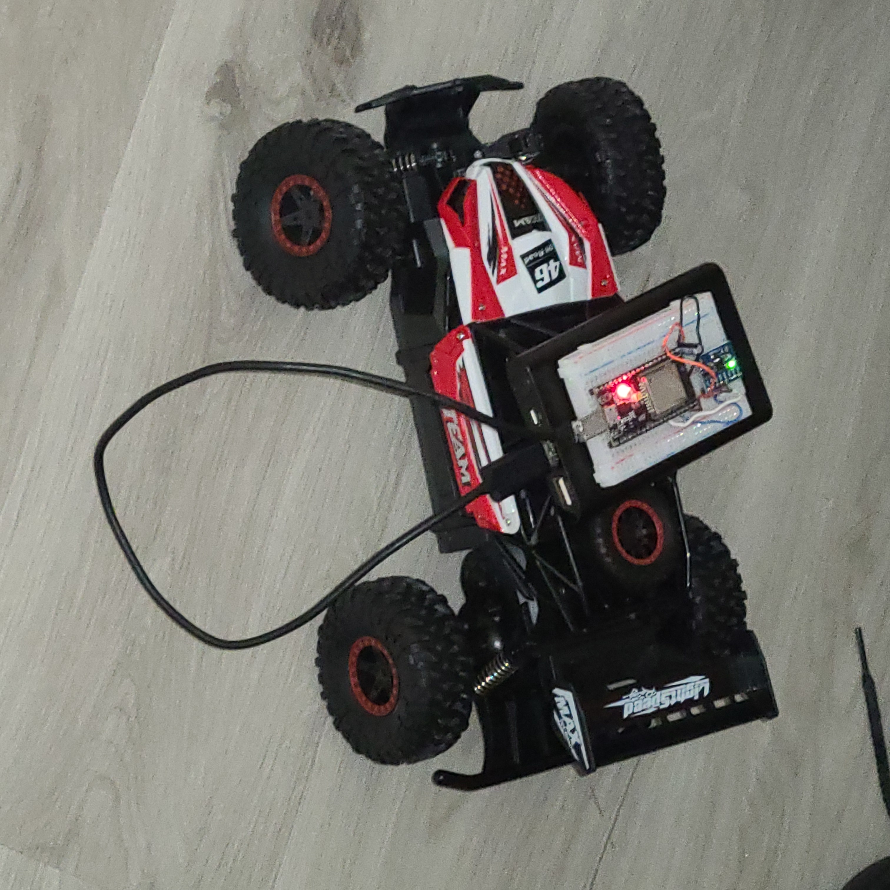

microcontroller picks up based on what the IMU senses. All the readings are accessed on any browser with the correct Wi-Fi IP address thanks to the web server and how it is configured.

Potential uses
This doesn’t necessarily have to be used for just a remote-control rover, but it can also be used for many other purposes. One example is that it can track if someone specifically with autism moves or rotates his head or hand too much remotely without having to shadow the patient. Another example is to track the rotation and acceleration of a space shuttle in the air remotely, although more advanced hardware and software will be necessary. Lastly, it can also be used to track remotely on a web server, whether a driver is going to slow of fast, or if the car flipped over in an accident.

